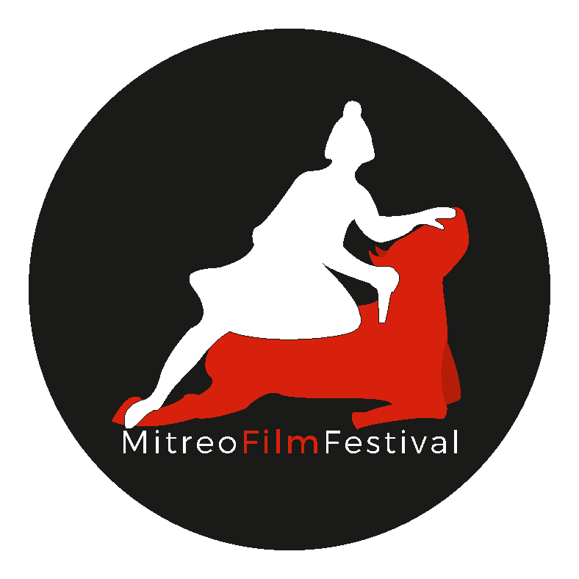

M I T R E O F I L M F E S T I V A L2 0 2 0

In partnership with

COORDINATION OF THE CAMPANI FILM FESTIVAL
MUNICIPALITY OF SANTA MARIA CAPUA VETERE
and the contribution of the CAMPANIA REGION

presents

INTERNATIONAL SHORT FILMS COMPETITION 2020
“YOUTH”

BEST SHORT FILM PRIZE 2020
duration: 10 minutes
author's age limit: 30 years
18/31 October

“Youth is happy because it has the ability to see beauty. Anyone who can maintain the ability to see beauty will never get old ”.
(Franz Kafka)

REGULATION
The cultural association Mitreo Film Festival, for the XXth edition of the homonymous festival, announces a call for selection for international short films lasting a maximum of 10 minutes, the theme is "YOUTH" and must be explicitly the heart of the story and the value around which the plot revolves, of whatever kind the short film is (drama, comedy etc ...).
The relevance to the theme must be clear and evident already in the synopsis of the work and / or in the director's notes that must accompany the application material, under penalty of exclusion.
The call is intended for authors who are under the age of 30 at 11.59 pm on 30 September 2020.
The short films must be strictly 10 minutes long and subtitled in Italian if in a different language.
The director of the short film is the author and owner of his rights.
The short film can be produced by small independent productions, but the representative and holder of the rights must still be the author who as such is a candidate for the competition.
Applications from distributors and manufacturers will NOT be considered.

This year the Competition will be entirely online and all the selected works will be screened on the MitreoFilmFestival website www.mitreofilmfestival.it where the public can express their preference. Among all the works entered on the Filmfreeway platform and the applications received, the staff of the MitreoFilmFestival2020 will select, at its sole discretion, 50 short films: 20 for the International Competition, 10 for the Competition Section Campani, 20 for the Out of Competition Section.
By October 15th, the MitreoFilmFestival staff will publish the names of the finalists and their works on the website.
The screening in the Teatro dei corti will only concern the finalist shorts and the award ceremony will take place during the final evening at the Garibaldi Theater, on October 31st, also in live streaming.

The Technical Jury composed of a representative of the staff of the MitreoFilmFestival 2020 and 4 professionals of the sector, including at least 1 foreign representative during the final evening of the MitreoFilmFestival 2020, will decide the winner of the INTERNATIONAL COMPETITION FOR SHORT FILMS - MITREOFILMFESTIVAL AWARD - BEST CORTOMETRAGE 2020 the cash prize will go together with the sculpture depicting the Mithraeum.
The winning author undertakes to mention the Award received and the MitreoFilmFestival 2020 in the titles of the short film.

The Youth Jury will award the cash prize together with the NO FEAR plaque, choosing the short film that will best be able to tell its story by daring with courage, innovation and experimentation. The winning author undertakes to mention the Award received and the MitreoFilmFestival 2020 in the titles of the short film.

The Corti Campani Jury composed of professionals in the sector will award the Best Short Campanian Award.

For the registration to be valid, the candidate must send the material listed below exclusively to the e-mail of the festival secretariat infoline@mitreofilmfestival.it by 11.59 pm on September 30, under penalty of exclusion:

1) application form and attached release, attached to this regulation, complete with the personal data of the candidate, drawn up in .pdf format and signed on each page;
2) curriculum from which the author's experience is deduced;
3) signed copy of an identity document properly scanned (.pdf file format);
4) link of the proposed short film;
5) synopsis of the proposed short film;
6) director's notes of the proposed short film;
7) copy of this regulation signed on each page;

On the FilmFreeWay platforms, it is recommended to also include the synopsis and director's notes of the work under penalty of exclusion from the selections
The selections will be made by the Staff of the MitreoFilmFestival 2020 and its judgment is final.
The selected authors undertake to send a high quality copy of the short film by 18 October. High quality files on pen and bluray will be accepted.
For everything not indicated in this announcement, the direction of the festival will decide.
The call is officially open from 8.00 on 22 August and closes on 30 September
This announcement can be downloaded from the website www.mitreofilmfestival.it
FOLLOWS APPLICATION FORM TO FILL IN

APPLICATION FOR PARTICIPATION IN THE SELECTION OF
THE INTERNATIONAL COMPETITION FOR SHORT FILMS MITREOFILMFESTIVAL 2020
(write in block letters and in an understandable way)

I, the undersigned ,
born in ______________________________________________the ___ _______
fiscal Code ___________________________________________,

resident in ____ in Via __________________________
phone ________________, e-mail _____________________________________________________________

I ASK

to be admitted to the International Competition for Short Films as part of the cultural event "MitreoFilmFestival 2020" (organized by the Cultural Association Mitreo Film Festival, based in Via G. Bonaparte, 20 - 81055, Santa Maria Capua Vetere (CE), tax code 94007300612 - hereinafter "Association" for brevity)
I DECLARE

to be in possession of the requirements of the announcement / regulation, to have read it and to accept it in all its points, attaching a signed copy as required;

to be the author (director), as well as the sole owner of his rights of use, of the short film entitled:
;

that the short film is visible on the link (the link must also be copied in the text contained in the email with which you apply so that you can click and be redirected to the video)

;

to be the only person responsible for my person, my equipment and my belongings for the duration of the MitreoFilmFestival 2020, and to exempt the Association and the staff assigned to the cultural event "MitreoFilmFestival 2020" from any damage to my person, to my things and to third parties.

I AUTHORIZE

the projection, by the Association, of the short film entitled

both during all the days of the festival and during all the collateral and promotional activities of the Association before and after the festival.

Place and date Signature

AUTHORIZATION TO DATA PROCESSING

In compliance with the disclosure obligation pursuant to art. 13 of the legislative decree 30 June 2003, n. 196, the undersigned declares to have been notified of the rights due pursuant to Article 7 of the aforementioned Legislative Decree no. 196/2003 and to have been informed that any information relating to him / her, acquired by virtue of this declaration and in the subsequent phases, will be processed in compliance with the provisions of Legislative Decree no. 196/2003. The person in charge of the treatment will be the Association. The undersigned acknowledges, in accordance with the law, the full legitimacy of the processing of data and, in particular, of his sensitive data and gives his consent to such treatment.

Place and date Signature

Attached all the material required for the selection including a copy of a valid identity document and the "regulation notice" signed on each page

